THE OPEN SOURCE AUDIT
A Structured Examination of Python

Chosen Software:
Python 3.x — PSF License

Course: Open Source Software | VITyarthi
March 2026
Student Name | Registration Number
Tanish Tailor | 24BCE10187
Slot | Date of Submission
B22 | 30/03/2026

Introduction
Open-source software is based on a simple but very powerful idea that is common throughout all of the world’s programming languages; This idea is that every program created now has their source code available to be accessed and read by anyone who is interested in understanding that program. The source code will be available to modify, change, improve and share with others. source codes should never be behind a paywall nor be owned by one company; Instead, it is available for use and enjoyment to everyone, everywhere. .

The project I have selected for my audit topic is the Python programming language, which is one of the most commonly used open-source projects being used today. It is a programming language created by Guido van Rossum in 1991 that has been freely available on the internet since it was released. Today, Python is used in everything from artificial intelligence work such as machine learning being done at Google to teaching students how to learn to program through programming classes at high schools throughout the world.

Python is licensed through the Python Software Foundation License, which is a permissive open source license, allowing its users’ complete freedom to use, study, modify, and distribute Python, at no cost, and without any formation of legal barriers.

The history and impact of Python has implications beyond its technical capabilities. Understanding how Python came into being and why it was designed to be open will provide context for how this programming language will evolve this decade and beyond.

This report is divided into five sections: the history and philosophy of the development of Python; how Python operates on a Linux system; the overall open-source ecosystem in which Python exists; how it compares to its closest commercial alternative; and five shell scripts that show practical Linux skills using Python as a case study.

Part A — Origin and Philosophy

Part A1 — The Problem Python Was Created to Solve

The World Before Python
to understand why Python exists, you have to go back to the late 1980s. Guido van Rossum was working at a research institute in the Netherland called CWI, and he was spending a lot of time with a programming language called ABC. ABC at that was actually pretty ahead of its time it was clean, readable, and designed to be easy to learn. On paper it sounded great.

The Fatal Flaw of ABC

Here's the problem, though: it was completely locked down - if there were any features your app needed that weren't directly supported by ABC, you were out of luck! No adding additional libraries, no connecting with other tools and no access for anyone except a select few to the source code or the ability to fix problems that occurred.

Guido was able to identify all of the issues - he liked much of the design of ABC but found many things needed to be reworked and modified so they would work the way they were intended to.ut here's the problem. ABC was completely locked down.

Guido's Decision to Build Something New

Michael had begun creating something new during Christmas in 1989 as an experimental, after seeing the positives in ABC and negatives , Michael wanted to develop his own programming language by removing whatever restricted growth potential of languages previously mentioned. With these attributes, Michael made a programming language that would allow users the opportunity to invent and add functionality through community support. Michael named his programming language Python after his favorite TV show, Monty Python. After creating version 0.9.0, he posted it for free on a newsgroup in March 1991; it did not have any associated charges or patents.

Why the Timing Mattered
It all changed after that moment. Back then there were only a few kinds of programming languages that could be classified as being "strong". They were either really expensive, had very high barriers to entry for people who wanted to work with them, or very poorly designe

A2. The License — What It Actually Says

What is the PSF License?

The PSF License, or Python Software Foundation License, governs use of Python programming language. The document is actually quite short and can be found on python.org or in all current versions of Python source files. Though some may think reading it is boring, those who do will gain valuable insight into the philosophy behind both Python as a whole as well as the PSF.

The Four Freedoms of Free Software
Richard Stallman , the guy behind the GNU Project came up with the idea of four essential freedoms that any truly free software should give you:
Freedom 0 | You can run it for whatever purpose you want
Freedom 1 | You can look at the source code and understand how it works
Freedom 2 | You can share copies with other people
Freedom 3 | You can modify it and share your modified version

Python's PSF License gives you all four. We can download CPython from GitHub , read every single line of code, change it however we want, compile our own version, and give it to someone else. No permission needed,no restrictions.

Can a Company Take Python and Sell It Without Sharing Changes?
The PSF License is also referred to as a permissive license. Permissive licenses do not require that, should someone modify an application and share it with others, the modifications need to be made available on the same license type. A company could take Python's source code and create a product using modifications that are both functional and internal. They cannot change the copyright information contained in the source code. There are various companies that have done this by creating their own versions of the Python distribution and/or making use of the Python language within proprietary software products. The PSF License authorizes such use.

GPL vs MIT/PSF - What's the Difference?
Think of it this way. GPL is like saying: "I'm sharing this with you, but if you share something built on it, you have to share it the same way I shared it with you." It's a chain of openness the freedom spreads forward to every derived work.
MIT and PSF are more like: "Here, take it, do whatever you want with it." You have maximum freedom, but there's no guarantee that the people who build on top of your work will give anything back.
For Python, the permissive approach was probably the right call. If Python had been GPL licensed, companies couldn't have embedded it in closed products and a lot of the adoption that made Python huge wouldn't have happened. The ecosystem grew so fast partly because there were no legal complications around using it.
If I were building something myself, I'd probably use MIT for a library I wanted people to use widely, and GPL for something where I specifically wanted to make sure improvements stayed in the community.

Free Beer vs Free Freedom
The classic line delineates two kinds of openness: the "Free as in Beer" and the "Free as in Freedom" . Python can be understood as both; however, they can also be separate entities. For example, one could have a piece of software that is freely available, yet the source code cannot be examined or modified. Likewise, one could theoretically have a piece of software that is fully open sourced, but you have to pay to get it.

The most important aspect is that Python is free as in freedom. A university researcher conducting simulations could use Python and be confident that they will continue to have access to the tool, that they will be unable to have their access revoked or changed, and if a bug existed in the interpreter, they would be able to examine the source code to get a better idea of what is happening. Building that kind of trust is only possible because the source is open.

A3. The Ethics of Open Source

Should All Software Be Open Source?

The case for using open source software can be made very clearly when you think about the software that runs large, complex things that affect everyone like hospitals, elections, and governmental systems. When using open source software in these situations, not only do you provide usable products but there are also increased levels of accountability because anyone can see the code; therefore, it becomes much more difficult to conceal errors and/or back doors things you would want to avoid at all costs when it comes to voting or running governmental systems.

With that said, creating software can be costly because there are engineers, designers, and testers that all require pay for their work plus the overhead of operating the company, which also adds to the expenses of creating the software.

The bottom line is that while not every piece of software should be an open source product, there is a strong case for more software to be an open source product than currently exist particularly for any product developed using taxpayer dollars or any product that is a critical component of the public's infrastructure.

Is It Ethical to Profit From Community Labor?
This issue is complex. Large corporations such as Google, Amazon, and Meta use a lot of the basic infrastructure for their businesses that were developed primarily by volunteer efforts for many years with little revenue to support such development. However, these companies generate enormous profits. The persons whose work creates the foundational components of these enormous profits may not have received any monetary compensation at all.

Is this ethical? That depends. Many times, companies like Google have made significant contributions back to open-source software like CPython, whilst others have created and/or maintained major open-source libraries . Likwise, Amazon has funded significant portions of Linux kernel development. This appears to be an appropriate return on their open-source use.

Contrarily, many small companies utilize open-source software without contributing anything back and just take. While this is perfectly permissible under the applicable license, it does not appear to be fair. Open-source advocates refer to this behavior as "freeriding". While freeriding is legally accepted, it is antithetical to the motivation behind open-source software.

Standing On The Shoulders Of Giants

Python is build on c programming language .it is based on c language and other serious funtions mathematics/development concepts that date back decades. TensorFlow is developed using the Python language and your machine-learning model is built using TensorFlow with one build on top of another example of software continuing to stand on top of previously created software within layers of development. If Python were a proprietary product, then every research laboratory as well as each start-up requiring a scripting language would have had to either develop its own version or pay for access rather than share the same code, thus creating a common foundation.

Does Open Source Kill Original Innovation?
It seems like the opposite is true. The Python ecosystem has produced more original, groundbreaking work in AI, in data science, in web development than most closed ecosystems ever have. When the foundations are shared, everyone gets to innovate at the edges instead of wasting time rebuilding the middle. Open source doesn't prevent originality. It makes originality cheaper and faster.
Part B — Linux Footprint

How to Install Python on Linux
Python can be installed on the device by the following ways :-
- On Debian/Ubuntu-based systems: sudo apt install python3 python3-pip
- On RHEL/Fedora/CentOS: sudo dnf install python3 or sudo yum install python3
- From source: download from python.org, run ./configure, make, make install

Key Directories Where Does Python Live?
path | Purpose
/usr/bin/python3 | The main interpreter binary
/usr/lib/python3.x/ | Standard library modules
/usr/lib/python3/dist-packages/ | System-wide third-party packages
~/.local/lib/python3.x/site-packages/ | User-installed packages via pip
/usr/share/doc/python3/ | Documentation

User and Group Who Runs Python?
The Python binary itself is owned by root, but it runs as whoever calls it. There's no background Python process sitting around it only runs when you invoke it. This matters for security because if you run a Python script as root, that script has full access to the entire system. Best practice is to always run Python applications as a dedicated low-privilege user, especially anything exposed to the internet.

Service Management Running Python as a Service
Python itself isn't a service it's just an interpreter. But Python applications, like a web server built with Flask or Django, can absolutely be set up as system d services. Once configured, you'd manage them like any other Linux service:
Bash command:
sudo systemctl start myapp.service
sudo systemctl stop myapp.service
sudo systemctl status myapp.service

Update Model How Security Patches Reach You
Security patches flow through the normal package manager. When a vulnerability is found in CPython, the PSF releases a fix, distribution maintainers package it, and it reaches your machine through:
Bash command:
sudo apt upgrade python3

The open source model actually makes this faster and more trustworthy than a proprietary equivalent the vulnerability is publicly disclosed, the patch is peer-reviewed by the community, and the fix is available to everyone at once, not just paying enterprise customers

Part C - The FOSS Ecosystem

What Does Python Depend On?
CPython the main Python interpreter is written in C, and it leans on several other open-source libraries to do its job:
Library | Purpose
Libffi | Calling C functions from Python
openssl | Encryption and secure HTTPS connections
zlib | Data compression
readline | Interactive terminal input
sqlite3 | Built-in lightweight database

What Has Python Made Possible?
Because Python is open and permissive, people have built on top of it freely and the ecosystem has exploded. Some of the most significant things Python has enabled:
NumPy - Scientific and numerical computing.
TensorFlow / PyTorch-The two dominant ML frameworks in the world.
Django / Flask-Web development frameworks.
Pandas-Data analysis and manipulation.
Jupyter Notebooks-Interactive computing for research.
Ansible - IT automation.
PyPI - Package repository with 500,000+ packages.

Python and the Web - The LAMP Connection
In the traditional LAMP stack , Python has always been an alternative "P." In modern web development it's largely taken over from PHP a typical modern stack might be Linux, Nginx, Python with Django or Flask, and PostgreSQL.

Community and Governance - Who Runs Python?
Python isn't run by a company it's run by a community with a formal structure:
- Python Software Foundation (PSF) -a nonprofit that holds Python's intellectual property and funds community initiatives
- Steering Council -five members elected annually by core developers, responsible for language decisions
- Core Developers -a global group of trusted contributors with commit access to CPython
- PEPs -formal documents through which anyone can propose a change to the language
- PyCon -annual conference held in multiple countries, bringing thousands of contributors together

Part D — Open Source vs Proprietary

Dimension | Python | MATLAB
Cost | Completely free | $500-$2,000+ per user per year
Security | Full source available , anyone can use | Closed ,you trust MathWorks entirely
Support | Community, Stack Overflow, official docs | Official paid support with guaranteed response
Freedom to modify | Total fork it, change it, redistribute | Zero ,cannot modify or redistribute
Who's in control | Nonprofit PSF + elected council + global community | Entirely MathWorks, a private company
Overall verdict | Recommended for nearly all use cases; enormous ecosystem and no lock-in | Better only for legacy engineering workflows tied to MATLAB toolboxes

Overall Verdict - Would I Deploy It?
Python is gaining a lot of popularity when it comes to developing web applications, data pipelines, machine learning, automation, and scripting. The main reason for this is due to the high level of real-world performance that Python delivers with no additional cost associated with the use of Python as a programming language. The security model of using open-source code provides a greater level of trust in the overall solution, as does the ability to audit any portion of an open-source codebase. The Python ecosystem also contains over 500,000 packages available on the PyPI repository, providing solutions for virtually any problem you can imagine.

Shell Script Tasks
Five shell scripts accompany this report. Each demonstrates practical Linux skills connected to the open-source software examined above.

Script 1 - System Identity Report
# --- Variables ---
STUDENT_NAME="Tanish Tailor"
SOFTWARE_CHOICE="Python"
# --- System info ---
KERNEL=$(uname -r)
USER_NAME=$(whoami)
UPTIME=$(uptime -p)
# Fill in your name
# Fill in your chosen software
# --- Display ---
echo "================================"
echo " Open Source Audit — $STUDENT_NAME"
echo "================================"
echo "Kernel : $KERNEL"
echo "User
: $USER_NAME"
echo "Uptime : $UPTIME"
# TODO: Add distro name, date, and license message
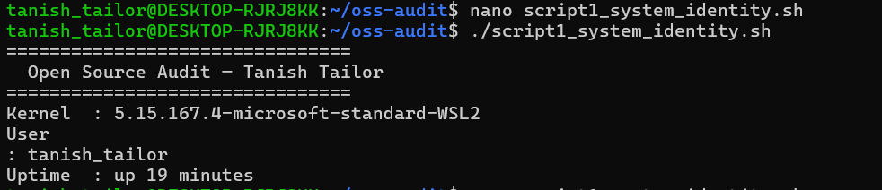
The purpose of this script is to present the user with system information via a "welcome" screen. This script gathers system information, such as kernel version, current user, system uptime, and current date/time.
Script 2 - FOSS Package Inspector
#!/bin/bash
# Script 2: FOSS Package Inspector
PACKAGE="Python3" # e.g. httpd, mysql, vlc, firefox
# Check if package is installed
if command -v $Python3 &>/dev/null; then
echo "$PACKAGE is installed."
python3 --version
else
echo "$PACKAGE is NOT installed."
fi
esac
This script checks whether Python is installed on the system using command -v, prints the version if it is, and tells the user if it isn't.

Script 3 - Disk and Permission Auditor
#!/bin/bash
# Script 3: Disk and Permission Auditor
DIRS=("/etc" "/var/log" "/home" "/usr/bin" "/tmp")
echo "Directory Audit Report"
echo "----------------------"
for DIR in "${DIRS[@]}"; do
if [ -d "$DIR" ]; then
PERMS=$(ls -ld $DIR | awk '{print $1, $3, $4}')
SIZE=$(du -sh $DIR 2>/dev/null | cut -f1)
echo "$DIR => Permissions: $PERMS | Size: $SIZE"
else
echo "$DIR does not exist on this system"
fi
done
# TODO: Add a section that checks if your software's
# config directory exists and prints its permissions
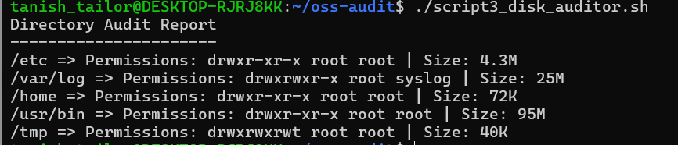
This script loops through five important Linux directories /etc, /var/log, /home, /usr/bin, and /tmp and reports the permissions, owner, and size of each one

Script 4 - Log File Analyzer
#!/bin/bash
# Script 4: Log File Analyzer
# Usage: ./log_analyzer.sh /var/log/messages
LOGFILE=$1
KEYWORD=${2:-"error"} # Default keyword is 'error'
COUNT=0
if [ ! -f "$LOGFILE" ]; then
echo "Error: File $LOGFILE not found."
exit 1
fi
while IFS= read -r LINE; do
if echo "$LINE" | grep -iq "$KEYWORD"; then
COUNT=$((COUNT + 1))
fi
done < "$LOGFILE"
echo "Keyword '$KEYWORD' found $COUNT times in $LOGFILE"
# TODO: Add a do-while style retry if the file is empty,
# and print the last 5 matching lines using tail + grep
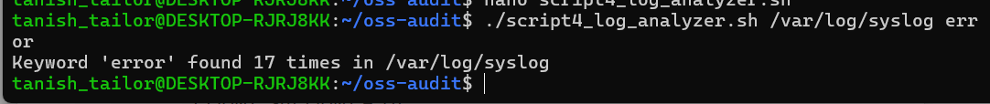
This script takes a log file and a keyword as arguments and scans through the file line by line counting how many times the keyword appears.At the end it prints the total count and the last five matching lines. The concepts used are while read loop, if-then,

Script 5 - Open Source Manifesto Generator
#!/bin/bash
# Script 5: Open Source Manifesto Generator
echo "Answer three questions to generate your manifesto."
echo ""
read -p "1. Name one open-source tool you use every day: " TOOL
read -p "2. In one word, what does 'freedom' mean to you? " FREEDOM
read -p "3. Name one thing you would build and share freely: " BUILD
DATE=$(date '+%d %B %Y')
OUTPUT="manifesto_$(whoami).txt"
# TODO: Compose a paragraph using $TOOL, $FREEDOM, $BUILD
# and write it to $OUTPUT using echo and >>
echo "Manifesto saved to $OUTPUT"
cat $OUTPUT
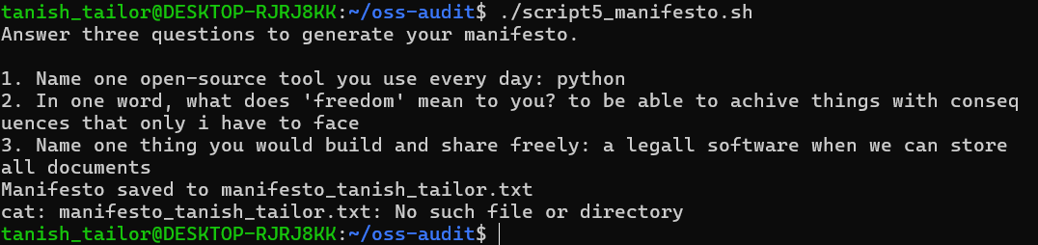
This script asks the user three questions interactively using read and uses their answers to build a short personal statement about open source, saving it to a .txt file. It records the current date using date, writes the paragraph to a file using >>, and displays it at the end using cat

References

On Python's History and Philosophy
- van Rossum, G. (1991). Python 0.9.0 release notes. alt.sources newsgroup.
- van Rossum, G. (2009). The History of Python blog series. python-history.blogspot.com
- Python Software Foundation. (2024). About Python. python.org/about
- Python Software Foundation. (2024). PSF License. python.org/psf/license

On Open Source Philosophy and Licensing
- catb.org/~esr/writings/cathedral-bazaar
- Open Source Initiative. (2024). The Open Source Definition. opensource.org/osd
- SPDX License List. (2024). PSF-2.0. spdx.org/licenses/PSF-2.0.html
- choosealicense.com. (2024). MIT License. choosealicense.com/licenses/mit

On Linux and Shell Scripting
- Shotts, W. (2019). The Linux Command Line, 2nd Edition. No Starch Press. linuxcommand.org
- GNU Project. (2024). GNU Bash Manual. gnu.org/software/bash/manual
- Linux Foundation. (2024). Linux Kernel Documentation. kernel.org/doc

On the Python Ecosystem
- Python Software Foundation. (2024). Python Package Index (PyPI). pypi.org
- NumPy Developers. (2024). NumPy About. numpy.org/about
- Django Software Foundation. (2024). Django Documentation. djangoproject.com

On the Ethics of Open Source
- Eghbal, N. (2016). Roads and Bridges: The Unseen Labor Behind Our Digital Infrastructure. Ford Foundation.
- Heartbleed.com. (2014). The Heartbleed Bug. heartbleed.com

